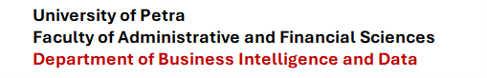



Netflix Content Analytics: Exploring Content Trends, Patterns, and Personalized Recommendations Using Data Analytics and Machine Learning

Authors

Abdallah Shaheer Sudqi Nasrallah
Student Number: 202010940

Supervised by
Dr. Wasef Matar

Course: 307498 – Graduation Project
First Semester, 2025/2027

Date 13/09/2026



Abstract 3
Acknowledgment 4
Business Intelligence Project description and objectives 5
Data Research and Acquiring Effort 8
Links to raw data 11
Data Description and understandings 11
Data Primary Cleaning and Transformation 13
Data Visualization and Insights 14
Advanced Analytics and AI Modeling 18
Tools Research and Selection Effort 20
Project Deployment Effort – Use Case 21
Results 23
References 25

Abstract
This Business Intelligence graduation project examines the Netflix Titles dataset to identify catalogue composition, content trends, geographic representation, genre patterns, and metadata-based recommendations. The supplied dataset contains 8,807 title records and twelve descriptive fields. The project applies data understanding, data cleaning, exploratory data analysis, visualization, dashboard planning, and a content-based recommendation prototype.
The analysis found 6,131 Movies (69.6%) and 2,676 TV Shows (30.4%). Recorded additions reach their highest total in 2019 with 2,016 titles. The United States, India, and the United Kingdom have the highest country associations, while International Movies, Dramas, and Comedies are the most frequent genre labels. The mean duration of movies is 99.6 minutes.
The AI component uses a content-based approach because the dataset has title metadata but no user ratings, viewing history, clicks, or completion information. Type, genre, description, director, cast, and country are transformed using TF-IDF, and cosine similarity ranks comparable titles. The result supports explainable related-title discovery rather than a claim of individual user personalization.
Keywords: Netflix, Business Intelligence, Data Analytics, Data Engineering, Exploratory Data Analysis, Machine Learning, TF-IDF, Cosine Similarity, Recommendation System, Power BI.

Acknowledgment
First and foremost, I would like to express my sincere gratitude to Dr. Wasef Matar, my project supervisor, for his valuable guidance, continuous support, constructive feedback, and encouragement throughout the development of this graduation project. His academic knowledge and insightful recommendations played an important role in guiding the project through its different stages and improving the quality of the final work.
I would also like to extend my sincere appreciation to the faculty members and staff for providing the knowledge, skills, and academic foundation required to complete this Business Intelligence project. The learning experience gained throughout my studies, particularly in data analytics, Business Intelligence, Artificial Intelligence, data visualization, and decision-support concepts, contributed significantly to the completion of this work.
Finally, I would like to express my deepest gratitude to my family and friends for their patience, motivation, and continuous encouragement throughout my academic journey. I am sincerely thankful to everyone who contributed directly or indirectly to the successful completion of this graduation project.

Business Intelligence Project description and objectives

Streaming catalogues contain thousands of titles and several layers of descriptive information. A Business Intelligence solution can organize these metadata fields into measures that support discovery and catalogue monitoring. This project analyzes the Netflix Movies and TV Shows dataset, a catalogue metadata source distributed through Kaggle [1]. It does not measure current availability, viewer behavior, subscriber growth, revenue, or content costs.

Problem Context
Content teams need concise views of portfolio composition and consistent metadata. Without a structured analytical view, it is difficult to compare Movies with TV Shows, identify frequently represented production countries and genres, monitor title additions over time, or find related titles through an explainable method. Recommendation research emphasizes the value of methods that help users identify relevant items in large information spaces [2]. The problem therefore concerns catalogue intelligence and content discovery within the limits of available metadata.

Target Market
The project is relevant to streaming-platform content analysts, catalogue operations teams, product discovery teams, and Business Intelligence analysts. Its outputs demonstrate how a media catalogue can be transformed into dashboards and a related-title prototype. This analytical direction is consistent with Netflix Research attention to recommendation systems and content discovery [3]. The same workflow can also apply to digital libraries, video-on-demand services, and other metadata-rich media collections.

Ethical and / Environmental Issues
The file contains public-style title metadata rather than viewer-level personal data, which limits privacy exposure. Still, missing values must not be interpreted as factual absence. The recommendation output may reproduce catalogue imbalance because it learns from the metadata available in the snapshot. Recommender-system literature identifies the need to consider transparency and unintended bias in system design [2]. A live system should apply data governance, transparent ranking explanations, accessibility checks, and efficient refresh routines to avoid unnecessary computing use.

Previous Studies
Gómez-Uribe and Hunt (2015) examined the role of recommender systems in Netflix’s product environment. Their study explained how recommendations support content discovery by helping users identify titles that are relevant to their preferences from a very large catalogue. The authors showed that recommendation systems are not only technical tools; they are also important for improving the customer experience and helping streaming platforms organize and present content effectively [1].
Lops et al. (2011) reviewed content-based recommendation systems and explained that these systems recommend items by comparing their descriptive features. Their study highlighted that content attributes such as categories, keywords, descriptions, creators, and other metadata can be used to identify similarities between items. This approach is particularly suitable for the Netflix dataset because it contains fields such as type, country, cast, director, genre, rating, and description, while it does not contain user ratings or viewing-history data [2].
Ricci et al. (2022) discussed the main approaches used in recommender systems, including content-based filtering, collaborative filtering, and hybrid methods. The authors explained that content-based recommendations are useful when user-interaction data are unavailable and when the available information focuses on item characteristics. Their findings support the use of a content-based recommendation model in this project because the dataset provides title-level metadata rather than individual users’ viewing behavior [3].
Aggarwal (2016) examined recommendation-system techniques and their business applications. The study emphasized that similarity-based methods can improve information retrieval and help users discover relevant items in large digital collections. The author also noted that recommendation quality depends strongly on the completeness, consistency, and relevance of the input data. This supports the importance of data cleaning and text transformation before building the Netflix recommendation model [4].
Davidson et al. (2010) described the large-scale recommendation system used by YouTube and demonstrated the value of combining content information with user behavior to improve content discovery. Although the Netflix dataset used in this project does not include user interactions, the study provides evidence that recommendation technologies are important tools for digital media platforms because they reduce search effort and support personalized discovery of videos and media titles [5].
Bennett and Lanning (2007) introduced the Netflix Prize competition and highlighted the importance of predictive models in improving movie recommendations. Their work demonstrated that data-driven recommendation methods can create value for streaming services by improving the relevance of suggested content. However, the Netflix Prize dataset included user ratings, whereas this project uses catalogue metadata only; therefore, the project applies a content-based recommendation method instead of collaborative filtering [6].
These previous studies demonstrate that recommendation systems are valuable for media and streaming platforms because they support content discovery, improve users’ ability to locate relevant titles, and transform large content catalogues into more usable information resources. Based on these studies, this project applies a content-based recommendation approach using Netflix title metadata, including genres, descriptions, cast, directors, countries, and content type.

Implications for the Project
The previous studies provide a clear foundation for developing the Netflix Content Analytics project. They show that recommendation systems can improve content discovery by helping users find titles that are relevant to their interests within large and complex media catalogues. Therefore, this project uses the Netflix dataset to transform raw title metadata into meaningful analytical insights and personalized content recommendations.
The studies also confirm that content-based recommendation systems are suitable when user-level data, such as ratings, watch history, clicks, or subscriber behavior, are unavailable. Since the Netflix dataset contains descriptive information about titles rather than individual customer interactions, the project relies on content attributes including genres, descriptions, directors, cast members, countries, ratings, and content type. These variables are combined to create a similarity-based recommendation model that suggests related Movies or TV Shows.
In addition, the literature emphasizes that the quality of recommendation outputs depends on the quality of the input data. For this reason, the project includes a detailed data-cleaning stage before conducting analysis or building the recommendation model. This stage addresses missing values, duplicate records, inconsistent text formatting, date conversion, and the separation of multi-value fields such as genres, countries, directors, and cast members. Clean and standardized data improve the reliability of both the visual analysis and the recommendation results.
The reviewed studies also demonstrate that data analytics can support strategic decisions in digital media businesses. Accordingly, the project does not focus only on recommending similar titles. It also analyzes content trends, including the distribution of Movies and TV Shows, the years in which content was added, frequently represented countries, common genres, ratings, and movie-duration patterns. These findings can support content analysts in understanding catalogue composition and identifying areas for future content acquisition or production.
Finally, the studies highlight the importance of transparency, responsible use of data, and awareness of model limitations. The recommendation model in this project should be interpreted as a title-similarity tool rather than a fully personalized Netflix recommendation engine. Because the dataset does not include customer preferences or viewing history, the recommendations are based only on metadata similarity. This limitation is stated clearly to ensure that the project’s findings and recommendations remain accurate, ethical, and consistent with the available data.

Summary of Background
The project combines Business Intelligence and machine learning in a single practical workflow. Descriptive analytics explains the catalogue, while the recommendation prototype uses metadata to support related-title discovery. The next sections document how the data was acquired, understood, cleaned, analyzed, and translated into dashboard and deployment outputs.

Data Research and Acquiring Effort

Planning Phase (Waterfall Approach)
The planning phase represents the foundation of the project and follows the principles of the Waterfall methodology, where each stage is defined and completed in sequence before progressing to the next stage. During this phase, the project title, objectives, scope, dataset, research questions, analytical methods, expected visualizations, recommendation-system approach, and final deliverables were identified clearly.
The project was planned as an academic Business Intelligence and Data Analytics project entitled “Netflix Content Analytics: Exploring Content Trends, Patterns, and Personalized Recommendations Using Data Analytics and Machine Learning.” The main objective is to analyze Netflix catalogue metadata in order to identify content patterns, compare Movies and TV Shows, explore genres and countries, examine catalogue growth over time, and develop a content-based recommendation system.
A preliminary review of relevant sources was conducted to identify appropriate methods for dataset analysis, data preparation, visualization, and recommendation modelling. The project workflow was organized around the main phases of data understanding, data preparation, exploratory data analysis, modelling, evaluation, visualization, and business recommendations. This sequence is consistent with the CRISP-DM framework, which emphasizes understanding the business objective, understanding the available data, preparing the data, building models, evaluating results, and presenting usable outputs [7].
The project scope was intentionally limited to the information available in the supplied Netflix dataset. Therefore, the analysis focuses on title-level metadata and does not attempt to measure actual Netflix subscriber behavior, viewing history, customer satisfaction, revenue, content-production costs, or real-time catalogue availability.

Data Collection and Preparation (Waterfall Approach)
Following the planning phase, data collection and preparation were conducted using a structured Waterfall approach. The primary source of data was the Netflix Movies and TV Shows dataset, originally made publicly available through Kaggle [1]. The dataset contains descriptive catalogue information about Netflix titles, including Movies and TV Shows.
The source file was provided in Microsoft Excel format and used as the main dataset for the project. It contains metadata fields that support Business Intelligence analysis and content-based recommendation modelling. The dataset includes title identifiers, title names, content type, directors, cast members, countries, dates added to Netflix, release years, ratings, duration, genres, and descriptions.
After acquiring the dataset, it was imported into Python for inspection and preprocessing. Several data-quality checks were performed before starting the analysis. These activities included:
- Examining the number of rows and columns in the dataset.
- Reviewing column names and identifying each variable’s data type.
- Checking for missing values in fields such as director, cast, country, date added, rating, and duration.
- Identifying duplicate title records.
- Converting the date_added column into a datetime format.
- Extracting the year and month from the date-added field for trend analysis.
- Standardizing text values by removing unnecessary spaces and ensuring consistent formatting.
- Separating multi-value fields, such as country and listed genres, to support country-level and genre-level analysis.
- Extracting movie duration in minutes and TV Show duration in seasons where applicable.
- Verifying that numerical fields, dates, and categorical variables were suitable for analysis.
The dataset was then transformed into a clean analytical format suitable for visualization, statistical summaries, dashboard development, and machine-learning modelling. Data preparation is a critical stage because inaccurate, incomplete, or inconsistent data can reduce the reliability of analytical insights and recommendation results [6].

Data Collection
The dataset used in this project was acquired from the Netflix Movies and TV Shows dataset published on Kaggle [1]. The dataset is a secondary-data source, meaning that the information was already collected and made available for analytical and educational purposes. No questionnaire, interview, experiment, or direct data collection from Netflix users was conducted in this project.
The supplied dataset contains approximately 8,800 Netflix titles and represents a catalogue snapshot of Movies and TV Shows. Each row represents one title, while the columns provide descriptive metadata about that title.
The dataset contains the following main variables:
- Title Identification Information
This group includes:
  - Show ID
  - Title
  - Content Type
  - Description
- Content and Production Information
This group includes:
  - Director
  - Cast
  - Country
  - Release Year
  - Rating
  - Duration
  - Listed Genres
- Netflix Catalogue Information
This group includes:
  - Date Added
  - Year Added
  - Month Added
  - Movie Duration in Minutes
  - TV Show Duration in Seasons
The data was collected in an Excel spreadsheet format and then imported into Python using the Pandas library. Python was used to conduct data cleaning, exploratory data analysis, trend analysis, visualization, and recommendation modelling. The final cleaned dataset was used to produce descriptive statistics, charts, dashboard-ready data, and a content-based recommendation prototype.
Because the dataset does not include user ratings, watch history, clicks, subscriptions, or demographic information, the project does not build a collaborative-filtering model. Instead, it uses a content-based recommendation approach based on available metadata, particularly genres, descriptions, cast members, directors, countries, and content type [2][3].

Links to raw data

Data Description and understandings

Data Engineering Overview
Data engineering converts raw records into a reliable analysis layer. In this project, the raw workbook retains the original fields while derived fields prepare dates, durations, and exploded category values for analysis. The process avoids changing the business meaning of a title record and documents all assumptions in the Python script.

Data Engineering Importance
High-quality inputs matter because summaries, dashboards, and recommendations inherit their reliability from the underlying fields. Consistent text improves grouping, datetime conversion enables trends, and separating duration units prevents the incorrect comparison of movie minutes with TV seasons. These steps reduce avoidable analytical errors and make the workflow reproducible.

Table 1. Data Source Profile.
Field | Data type | Project use
show_id | Text | Record identifier
type | Categorical | Movie or TV Show comparison
title | Text | Title search and model query
director and cast | Text | Creative metadata in recommendations
country | Multi-value text | Country representation
date_added | Datetime | Catalogue addition trends
release_year | Integer | Release chronology
rating | Categorical | Maturity-rating analysis
duration | Text | Movie minutes or TV seasons
listed_in | Multi-value text | Genre analysis
description | Text | Synopsis similarity

Descriptive Analysis
The file contains 8,807 records and 12 columns. There are no fully duplicated records. Data profiling showed missing values in director, cast, country, date_added, rating, and duration. These fields are handled differently depending on whether the analysis requires a valid date, numerical duration, or descriptive label.

Pivot Tables and Charts
Pivot-style grouped summaries calculate counts by content type, date-added year, country, genre, and rating. Countries and genres are multi-value fields, therefore a single title may appear in more than one country or genre count. The dashboard model should use bridge tables for these analyses so the main title count remains correct.

Data Primary Cleaning and Transformation

Table 2. Missing Values in the Original Dataset.
Field | Missing values before cleaning | Treatment
director | 2,634 | Unknown label
cast | 825 | Unknown label
country | 831 | Unknown label
date_added | 10 | Retained as missing or parsed
rating | 4 | Unknown label
duration | 3 | Retained as missing or parsed

Data Cleaning Process
The cleaning procedure first checked for duplicate records. It then standardized leading, trailing, and repeated whitespace, converted selected missing descriptive fields to Unknown, converted date_added to datetime, and extracted duration_value and duration_unit from duration. Country and listed_in fields were split only in temporary analytical tables used to count individual labels.

Data Transformation Process
date_added_year supports title-addition trends. duration_value stores a numerical amount, while duration_unit differentiates min and Season. The content_features field concatenates type, listed_in, description, director, cast, and country for the recommendation model. The script exports a cleaned CSV without overwriting the original workbook.
Table 3. Descriptive Statistics of Main Netflix Content Variables.
Quality check | Result | Interpretation
Dataset shape | 8,807 rows x 12 columns | Complete source profile
Fully duplicated records | 0 | No duplicate rows removed
date_added missing | 10 | Excluded only from year-added trend
Movie duration mean | 99.6 minutes | Calculated from Movie records with minute values
Recommendation vocabulary | 271,968 terms | Generated from selected text features

Data Visualization and Insights

Exploratory Data Analysis EDA
EDA was iterative. Initial results guided subsequent questions about type mix, additions by year, country representation, genre composition, ratings, and movie duration. The process used counts and distributions because the dataset does not provide financial or engagement measures.

Content Type Analysis
Movies represent 69.6% of the catalogue (6,131 titles), while TV Shows represent 30.4% (2,676 titles). This establishes the main catalogue composition KPI.
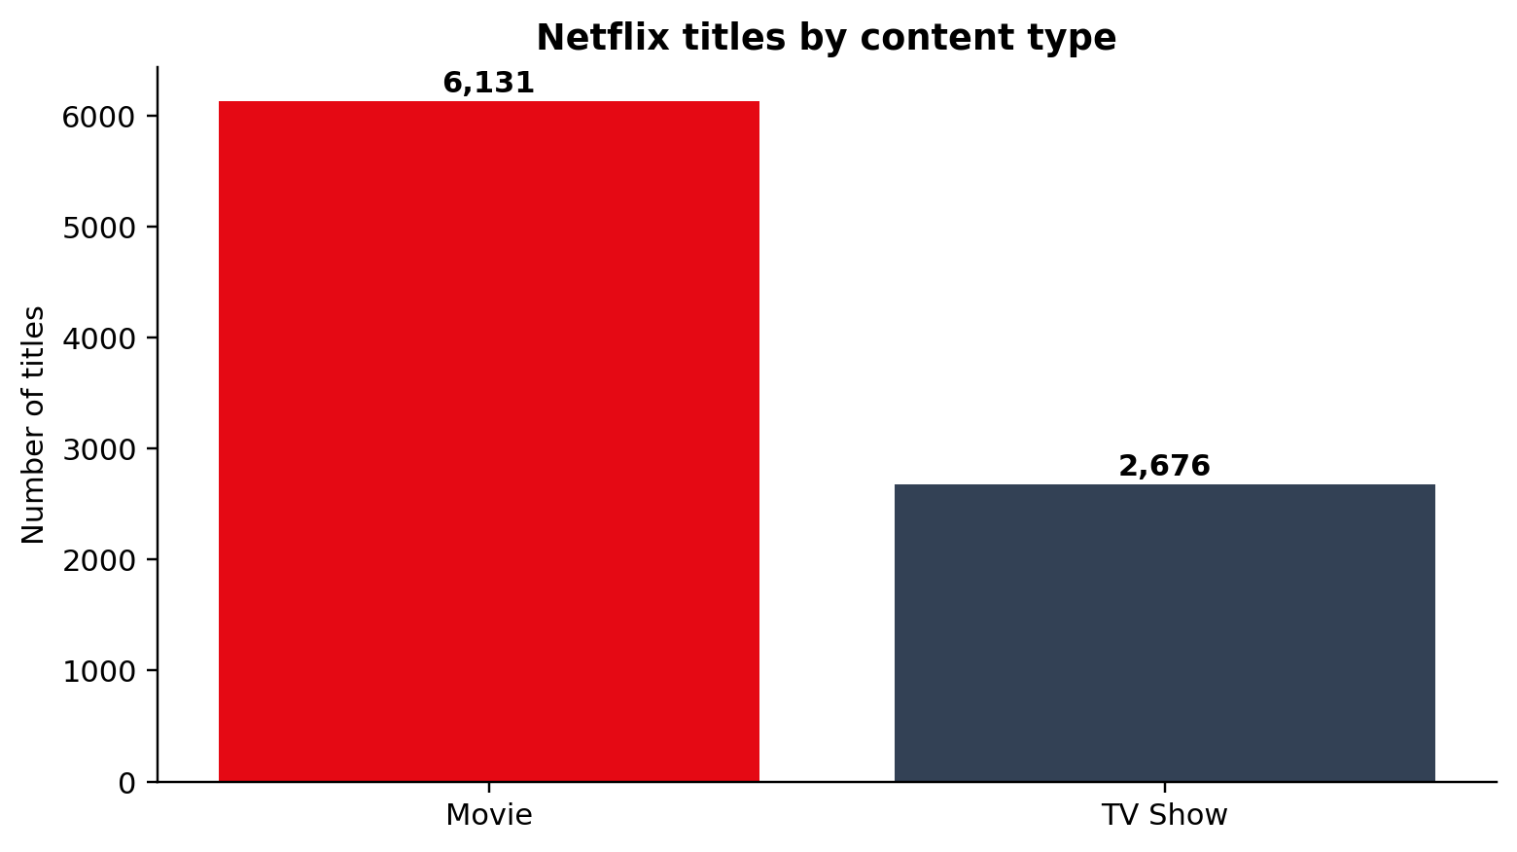
Figure 1. Netflix Titles by Content Type.

Time Trend Analysis
Titles added to the dataset rise during the late 2010s and peak in 2019 at 2,016 records. The final years in the snapshot should not be interpreted as complete annual production or content-release history.
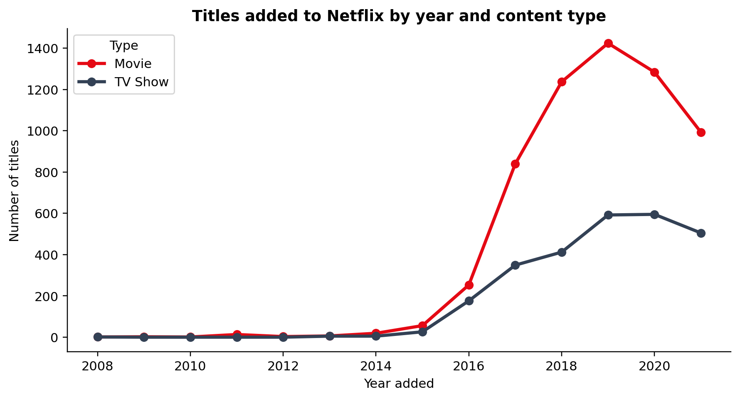
Figure 2. Titles Added by Year and Content Type.

Country Analysis
The United States has the largest number of country-title associations (3,690), followed by India (1,046) and the United Kingdom (806). Counts reflect multi-country metadata and do not indicate investment or audience size.
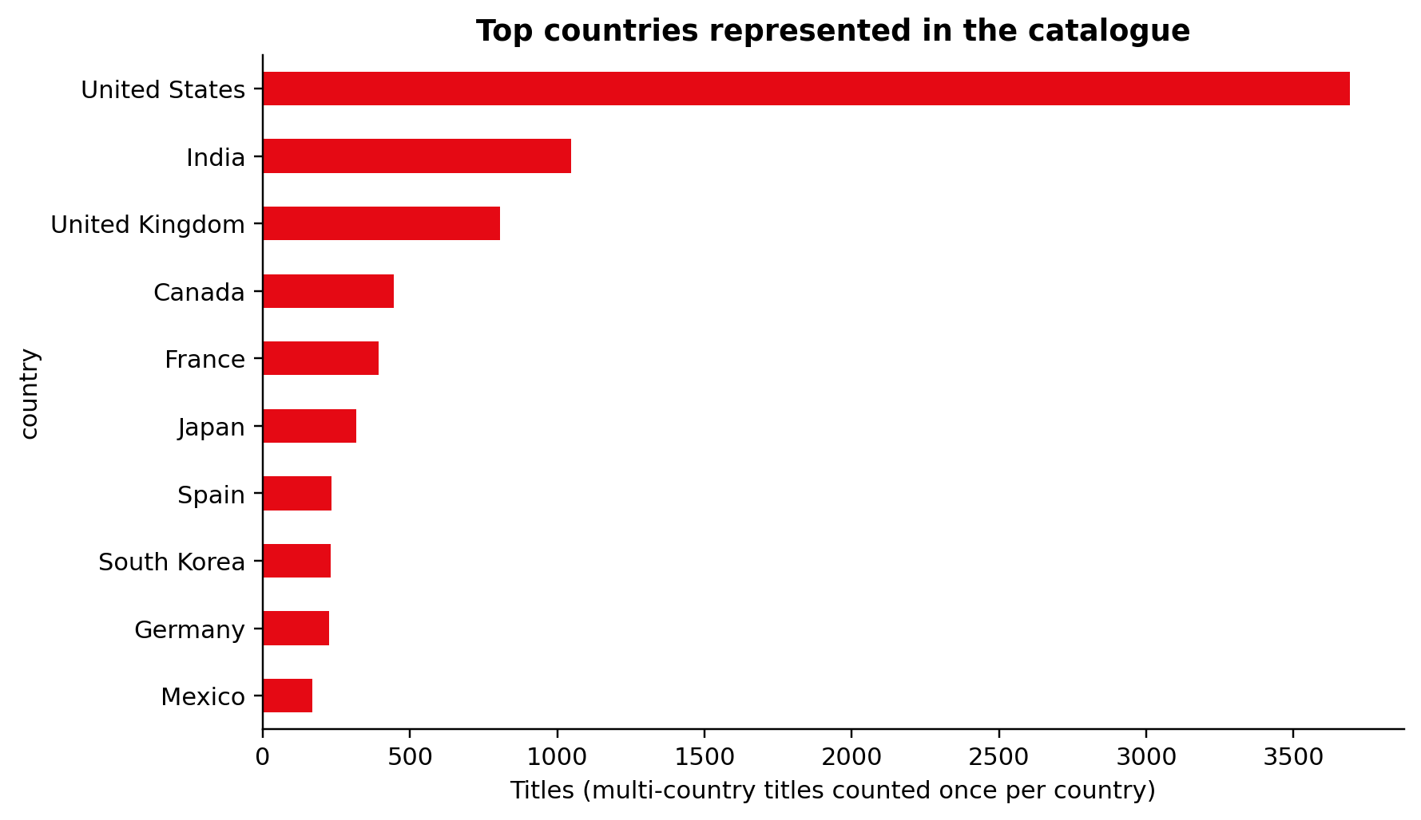
Figure 3. Top Countries Represented in the Catalogue.

Genre and Duration Analysis
International Movies (2,752), Dramas (2,427), and Comedies (1,674) are the most frequent genre labels. The mean movie duration is 99.6 minutes and the median is 98.0 minutes.
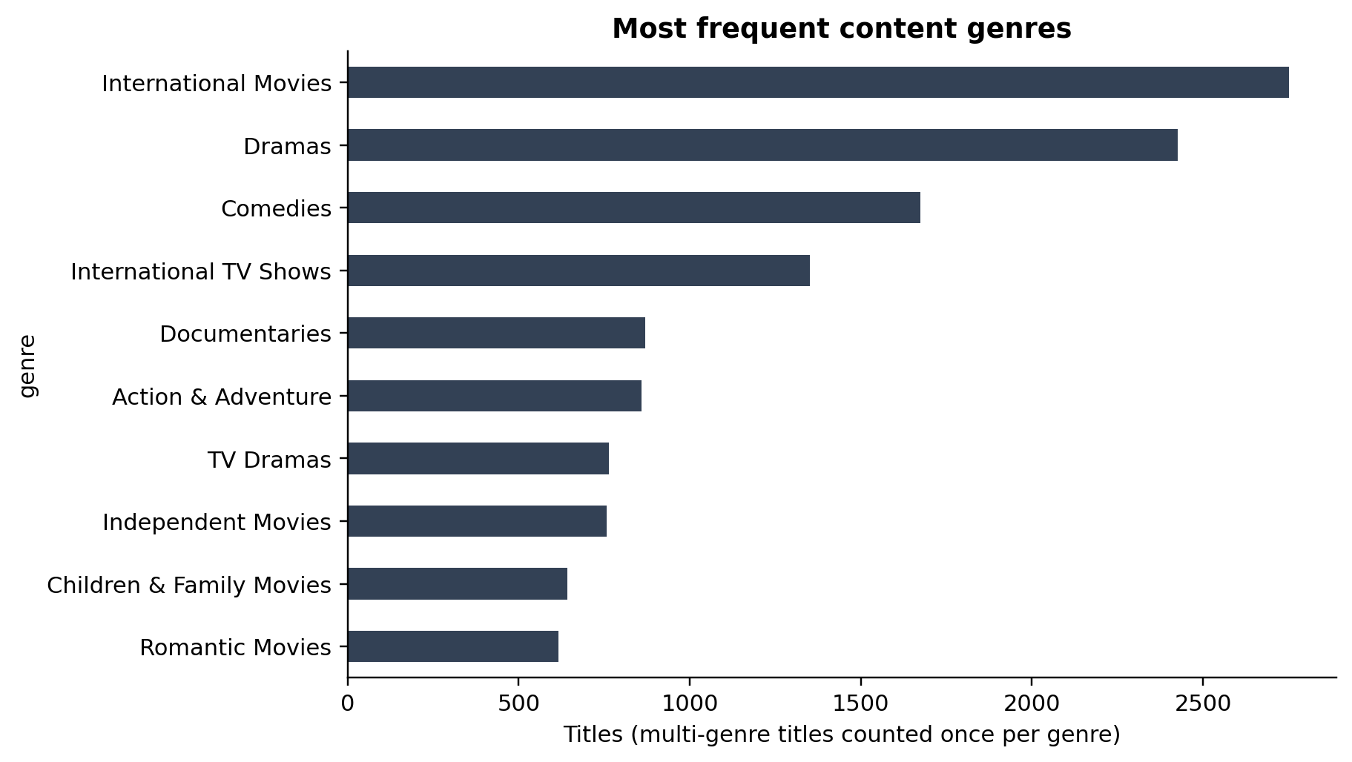
Figure 4. Most Frequent Content Genres.

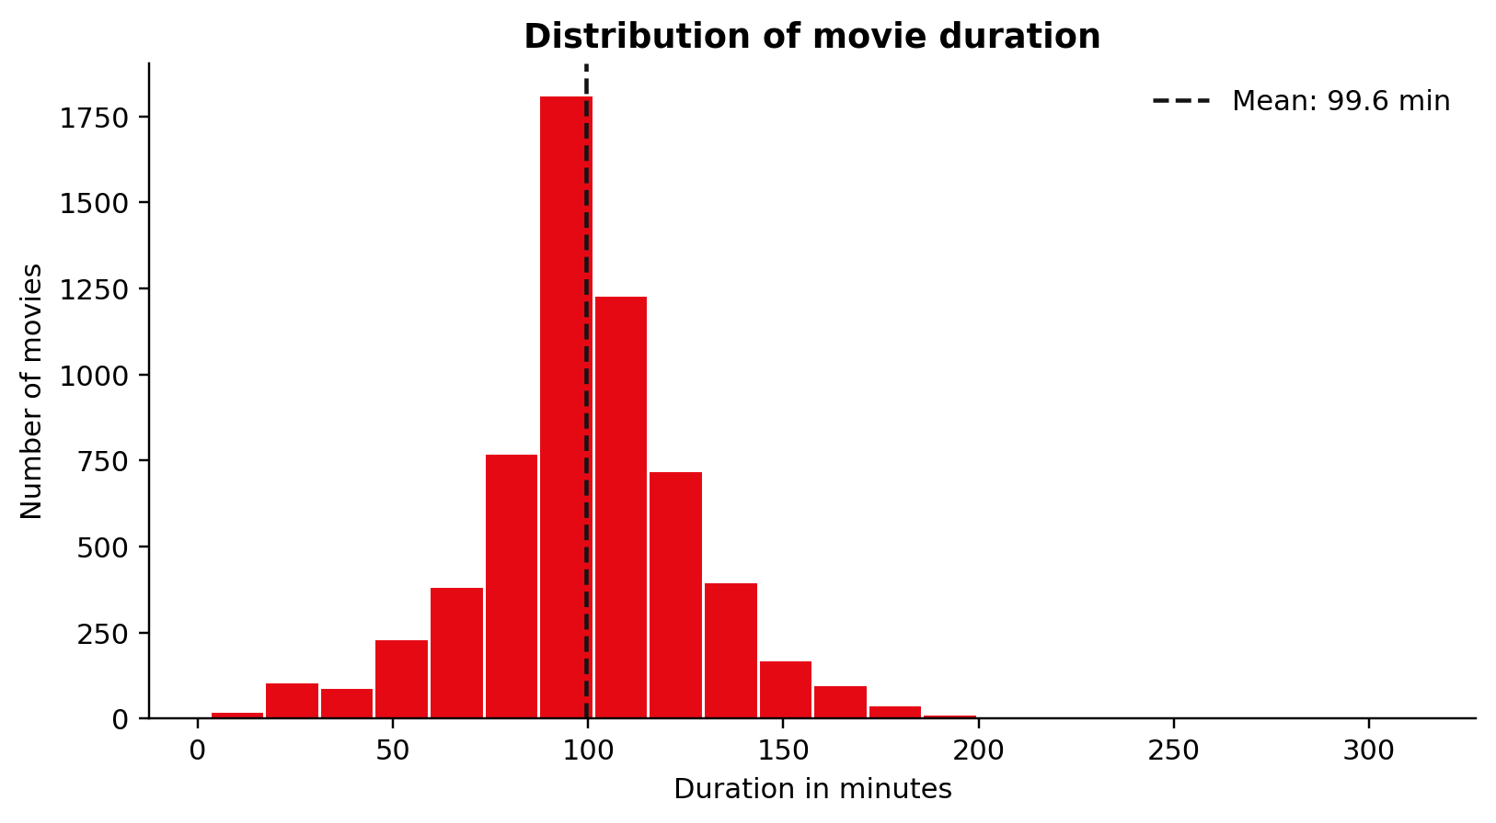
Figure 5. Distribution of Movie Duration.

Table 4. Most Frequent Naturity Eatings.
Rating | Titles
TV-MA | 3,207
TV-14 | 2,160
TV-PG | 863
R | 799
PG-13 | 490
TV-Y7 | 334
TV-Y | 307
PG | 287
TV-G | 220
NR | 80

Advanced Analytics and AI Modeling

Agile Approach Exploratory Data Analysis EDA
EDA used short iterative cycles: form a question, create a summary or visualization, review its meaning and limitations, refine the next question, and document the result. This approach is appropriate because exploration may reveal missing values, multi-label fields, or misleading aggregations that require a different preparation step.

Model Development Agile Approach
The model-development stage considered the data available. Collaborative filtering was excluded because the dataset has no users, ratings, views, clicks, or watch time. A content-based approach was selected because it can calculate similarity from title metadata.

Models and Evaluation
TF-IDF converts title metadata into weighted text features. Cosine similarity compares the normalized feature vectors and ranks titles with related metadata [4]. The project uses the scikit-learn implementation, an established open-source machine-learning library [5]. This approach is reproducible and transparent; however, it cannot report accuracy, precision, recall, or user satisfaction without a relevance dataset. Future evaluation requires interaction data and measures such as precision at k, recall at k, coverage, and diversity.
Table 5. Recommendation-model Configuration.
Component | Implementation
Model type | Content-based recommendation
Text features | type, listed_in, description, director, cast, country
Vectorization | TF-IDF with unigrams and bigrams
Similarity measure | Cosine similarity via linear kernel
Example query | Stranger Things
Model input records | 8,807 titles

Table 6. Recommendation example for Stranger Things.
Rank | Recommended title | Type | Similarity score
1 | Beyond Stranger Things | TV Show | 0.458
2 | Prank Encounters | TV Show | 0.096
3 | The Umbrella Academy | TV Show | 0.088
4 | Nightflyers | TV Show | 0.077
5 | Helix | TV Show | 0.071
6 | Manifest | TV Show | 0.07
7 | Anjaan: Special Crimes Unit | TV Show | 0.069
8 | Warrior Nun | TV Show | 0.069

Beyond Stranger Things ranks first because it shares direct franchise-related terms and TV metadata. The remaining results share combinations of mystery, science-fiction, horror, action, or related TV labels. The score is a relative metadata-similarity value, not a probability that a person will enjoy the title.

Tools Research and Selection Effort

Table 7. Tools Research and Selection.
Tool / Technology | Use in the Project | Reason / Contribution
Microsoft Excel | Input storage and review | Provides the supplied structured source file
Python | Cleaning, aggregation, figures, and modeling | Reproducible analytical workflow
Pandas | Data transformation | Tabular loading, cleaning, grouping, and export
Matplotlib | Charts | Static figures for the academic report
scikit-learn | Machine learning | TF-IDF vectorization and cosine similarity
Power BI or Tableau | Dashboard deployment | Interactive KPIs, filters, and trends

Project Deployment Effort – Use Case

Implementation and Reporting Waterfall Approach
Once cleaning, charts, and recommendation logic are validated, the project can be deployed as a dashboard plus a lightweight recommendation search. The deployment does not require a complex production model for this academic deliverable. It requires refreshable data, clear title-level measures, bridge tables for multi-value fields, and a documented recommendation function.

Advantages of a Hybrid Approach
Structured preparation ensures traceability from the workbook to the final KPIs. Agile exploration makes it possible to test charts and model features repeatedly. Together, these approaches provide control over data quality and flexibility during analysis.

Table 8. Business Use Case.
Use case element | Description
Business user | Content analyst, catalogue operations analyst, or product discovery analyst
Primary goal | Understand catalogue composition and find related titles
Input | Cleaned Netflix title metadata and selected query title
System process | Refresh data, calculate KPIs, apply filters, vectorize features, and rank titles
Output | Dashboard views, data-quality indicators, and a related-title list
Constraint | No viewer-level personalization or engagement prediction

Implementation Sequence
- Load the workbook and profile fields.
- Apply cleaning and transformation rules.
- Export a cleaned CSV and chart-ready summaries.
- Create EDA figures and verify KPI values.
- Build TF-IDF features and cosine similarity rankings.
- Create the dashboard using a Titles table and bridge tables.
- Document results, limitations, recommendations, and future work.

Agile Scrum Weekly Sprints
Table 9. Agile Sprint Plan.
Sprint | Focus | Output
Week 1 | Scope and data understanding | Project plan, data dictionary, and quality profile
Week 2 | Cleaning and transformation | Cleaned file and derived fields
Week 3 | EDA and dashboard measures | Figures, KPI definitions, and business insights
Week 4 | Recommendation prototype | TF-IDF model and test queries
Week 5 | Deployment and reporting | Dashboard specification and final documentation

Results

Insights
The analysis shows a movie-heavy catalogue, with 69.6% Movies. The highest recorded year for additions is 2019. The country and genre results show broad representation, but they require multi-value handling. The recommendation prototype demonstrates that available metadata can return transparent related-title results even when user interaction data is unavailable.

Business Implications
A content team can use title-level KPIs to monitor portfolio composition and data completeness. Country and genre analyses can help catalogue teams explore representation and tagging patterns. A similarity prototype can assist discovery teams by exposing related titles; it should not replace editorial judgment or be presented as personalized recommendations without preference data.

Summary of Findings
Table 10. Summary of Findings.
Finding | Evidence | Interpretation
Catalogue type mix | 6,131 Movies and 2,676 TV Shows | Movies dominate the snapshot
Peak recorded additions | 2,016 titles in 2019 | Recorded additions concentrate in late 2010s
Leading country association | United States: 3,690 | Country field is multi-value metadata
Leading genre label | International Movies: 2,752 | Genre field is multi-value metadata
Recommendation method | TF-IDF and cosine similarity | Appropriate for item metadata without interactions

Recommendations
- Use a Titles table for title-level KPIs and bridge tables for exploded country and genre analyses.
- Treat Unknown director, cast, country, rating, and date information as a metadata-improvement queue.
- Use content type, genre, and time trends for catalogue monitoring, not for unsupported claims about customer preference.
- Use the prototype for related-title discovery and add consented interaction data before introducing personalization.
- Evaluate future recommenders through relevance, diversity, coverage, and fairness measures.

Future Work
Future versions can include viewer interaction data, search queries, completion rate, language, availability window, content costs, and rating outcomes. These additions would enable collaborative or hybrid recommendations, robust offline evaluation, audience segmentation, and stronger decision-support analysis. A production deployment should also include automated quality checks, scheduled refreshes, access controls, monitoring, and periodic model review.

References

[1] Bansal, S. (2021). Netflix Movies and TV Shows [Data set]. Kaggle. https://www.kaggle.com/datasets/shivamb/netflix-shows
[2] Ricci, F., Rokach, L., & Shapira, B. (Eds.). (2022). Recommender systems handbook (3rd ed.). Springer. https://doi.org/10.1007/978-1-0716-2197-4
[3] Netflix Research. (n.d.). Recommendations. https://research.netflix.com/research-area/recommendations
[4] scikit-learn developers. (2026). TfidfVectorizer and cosine_similarity documentation. https://scikit-learn.org/stable/modules/metrics.html
[5] Pedregosa, F., Varoquaux, G., Gramfort, A., et al. (2011). Scikit-learn: Machine learning in Python. Journal of Machine Learning Research, 12, 2825-2830. https://jmlr.org/papers/v12/pedregosa11a.html
[6] McKinney, W. (2010). Data structures for statistical computing in Python. Proceedings of the 9th Python in Science Conference, 56-61. https://doi.org/10.25080/Majora-92bf1922-00a
[7] Shearer, C. (2000). The CRISP-DM model: The new blueprint for data mining. Journal of Data Warehousing, 5(4), 13-22.
[8] Aggarwal, C. C. (2016). Recommender systems: The textbook. Springer. https://doi.org/10.1007/978-3-319-29659-3

